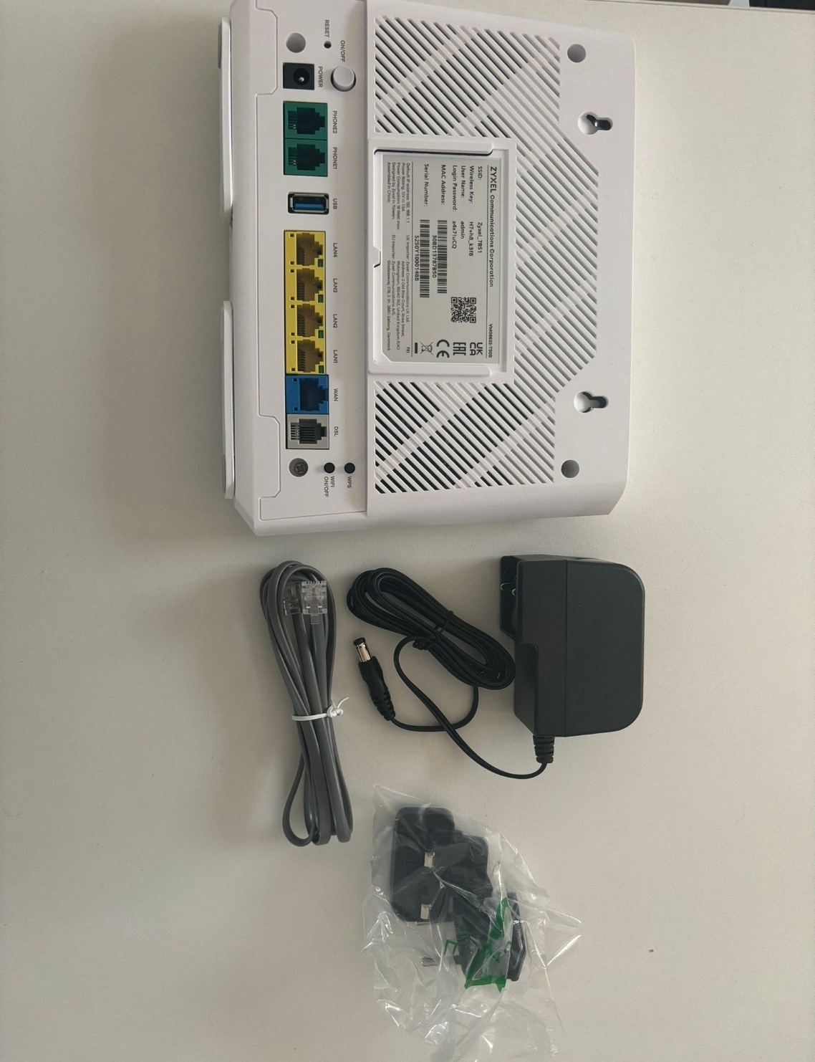
How to Connect Router to NTE BT Socket – Sogea

From the router box, find the power pack and the small grey DSL cable.
- Insert the power pack plug into the power adaptor (it will fit into the ridged port).
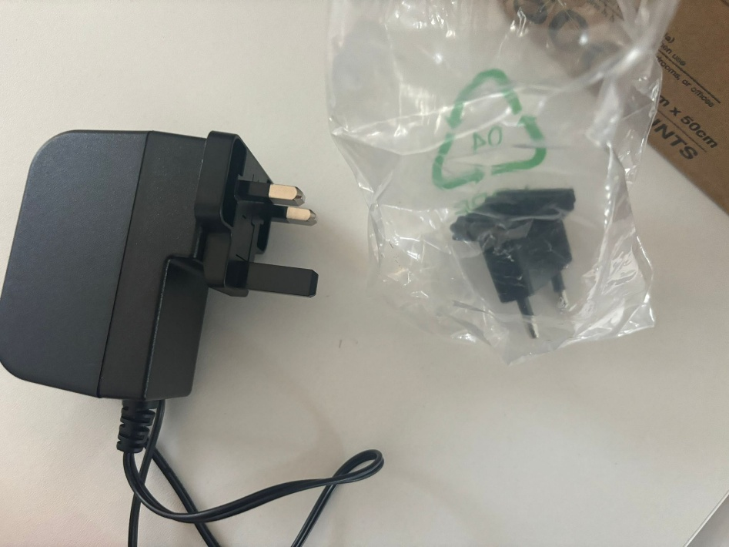

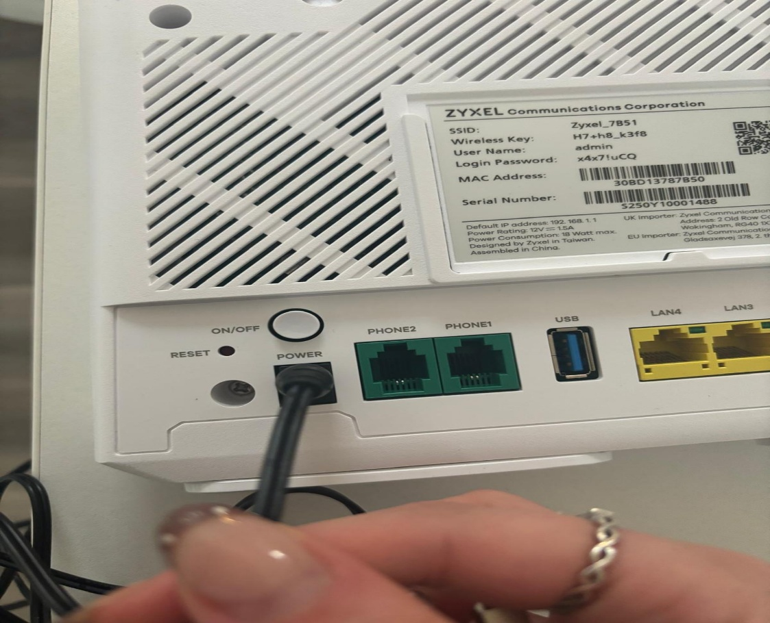
2) Insert the power pack plug into the power port on the router. If your router has an on/off button (circled on the diagram), press it to switch the router on.

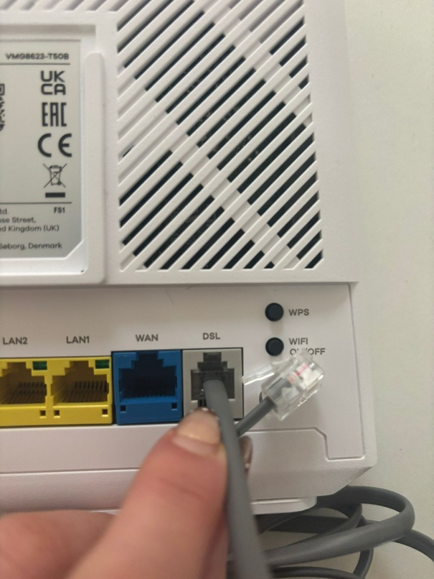
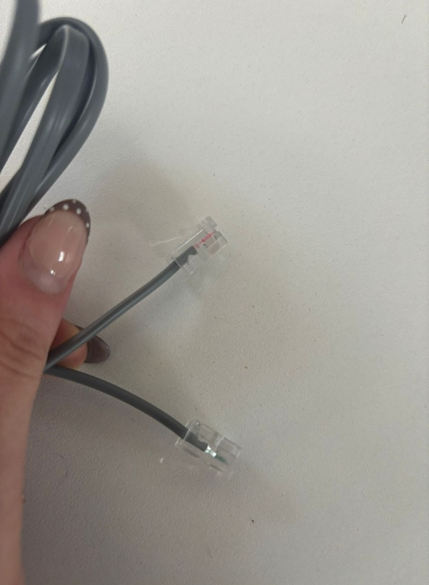
- Take the grey DSL cable and insert one end into the grey DSL port on the router.

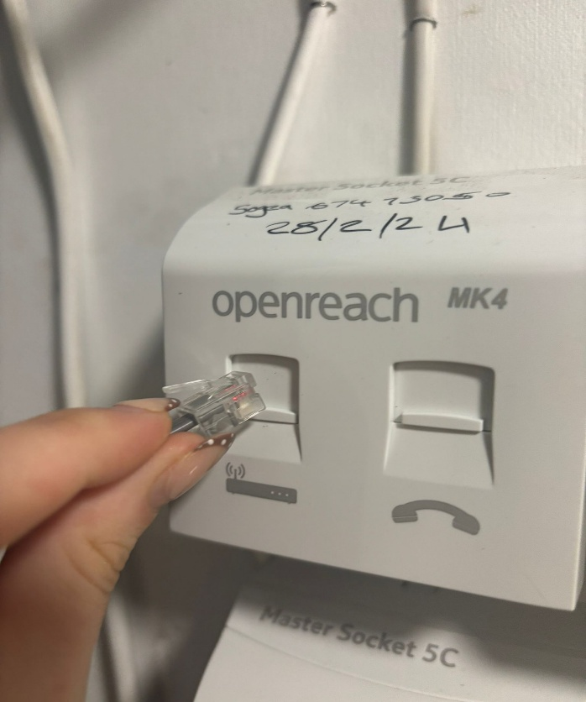
- Locate your BT wall socket, then plug the other end of the DSL cable into the “modem” port on the socket.
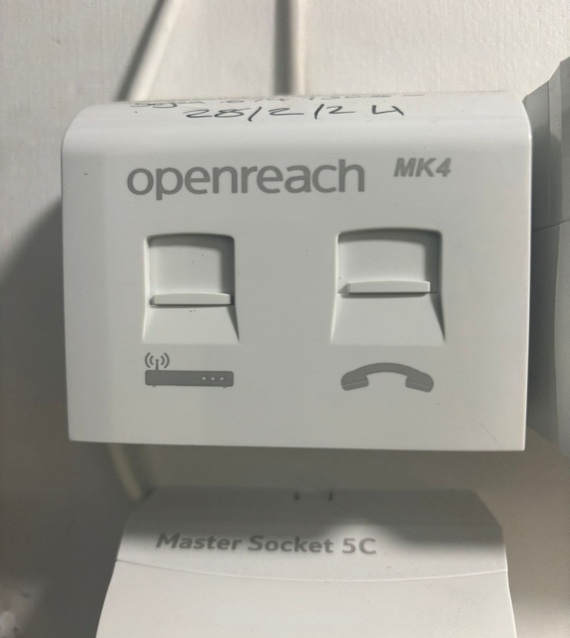

- The indicator lights on the router should now turn on. Once they stabilize, your Wi-Fi network will be available. You can connect any wired devices directly to the router using Ethernet Cables. Plug these into the LAN ports on the back of the router (Yellow Ports)

